Email from executive to employee campaign coordinator

Have a member of your executive team send this email to your organization’s selected employee campaign coordinator (ECC).

Subject line: Leadership development opportunity with our United Way campaign


Dear «Name»,

As you know, giving back to our community is an important part of «Company»’s corporate responsibility efforts, including our annual United Way campaign.
I am delighted to ask you to be this year's United Way employee campaign coordinator. Your passion for community, professionalism, and commitment to personal growth stand out as reasons why I would like to extend this exciting opportunity to you. It’s a chance to further develop your leadership skills, increase your exposure to our executive team, connect with your peers, and lead team-building and engagement strategies.

As an employee campaign coordinator, you will manage a team of volunteers to lead «Company»’s United Way campaign. This includes working with United Way, recruiting and mobilizing employee volunteers, planning and hosting employee events, coordinating volunteer activities, and being an advocate for our community and company as we rally employees to get involved.

This is a unique leadership development opportunity to grow and further develop the skills you have in these areas. I hope you have fun and feel empowered as you and your volunteer team organize our United Way campaign.

If you would like to discuss the position further or have questions, please don’t hesitate to contact me. United Way is also available to help and has resources to support you in this role.

Thank you so much for your support and helping «Company» create ripples of positive impact in our community. (Re)United, we make the biggest difference.

Sincerely,

«Executive Signature»

Email from ECC to volunteers

Get your United Way campaign team ready in advance – recommended time to send this email is two months prior to kicking off your campaign.

Subject line: Let’s be (Re)United for good with our United Way campaign!

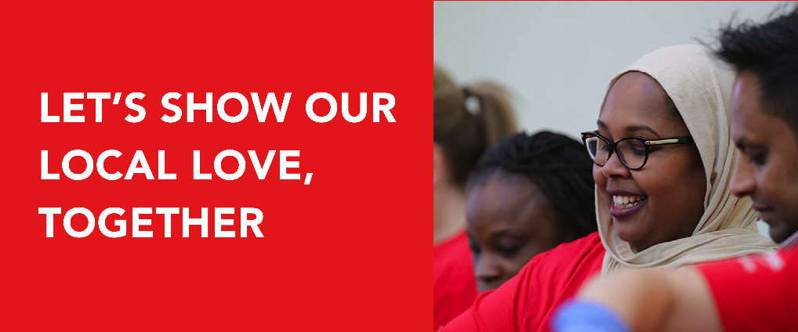

Dear «Name»,

«Company»’s United Way campaign is right around the corner, and I’m hoping I can count on your help! I’m looking for energetic, organized, and creative people like you to join our United Way campaign volunteer team.

Together, we will plan team-building events and activities, engage and rally employees to take part, demonstrate our corporate values, and give back to the community. By joining this team, you will have the opportunity to develop new skills that you can leverage for future work projects. You will also play an integral role in improving local lives and creating a resilient and caring community where everyone thrives.

Please let me know if you would like to join me as part of «Company»’s United Way campaign volunteer team. I’m excited to bring our organization together to create ripples of positive impact in our community. (Re)United, we make the biggest difference.

Sincerely,

«Company»’s United Way Employee Campaign Coordinator
«Signature»

